ONLINE ASSESSMENT PROCTORING SYSTEM



Submitted By

Ramla Rahman and 20949
Adila and 20397

Session 2022-2026

Supervised BY
Supervisor Muhammad Abrar Khan

A project proposal submitted to The IQRA National University, Peshawar in partial fulfillment of the requirements for the degree of

BACHELOR OF SCIENCE (BS) IN SOFTWARE ENGINEERING

DEPARTMENT OF COMPUTER SCIENCE
IQRA NATIONAL UNIVERSITY, PESHWAR-PAKISTAN
DECEMBER, 2025

Table of Contents

List of Figures ii
List of Tables iii
List of Acronyms iv
Introduction 1
Literature Review 1
Problem Statement 1
Objectives of Project 1
Methodology for Implementation of Project 1
Project Proposed Time Schedule 2
Budget Description 2
References 3
Undertaking 4
Supervisor Comments 4
FYP Coordinator Remarks 5

LIST OF FIGURES
Fig. No. Fig. Description Page No.
1.1 Flow Chart Diagram 2

LIST OF TABLES
Table. No. Table. Description Page No.
1 List of Acronym IV
2 Project Proposed Time Schedule 3
3 Estimated Budget 3

LIST OF ACRONYMS

ACRONYMS | DESCRIPTION
INU | IQRA National University
WWW | World Wide Web
OAPS | Online Assessment Proctoring System
AI | Artificial Intelligence
CV | Computer Vision
MERN | MongoDB, Express.js, React.js, Node.js
WEBCAM | Web Camera
ML | Machine Learning

Introduction
The rapid advancement of information and communication technologies has significantly transformed recruitment and evaluation processes across various industries. Organizations increasingly rely on digital platforms to conduct hiring activities, resulting in the widespread adoption of online interviews. Online recruitment offers numerous advantages, including reduced operational costs, geographical flexibility, and the ability to access a diverse pool of candidates. As a result, online interviews have become a standard practice in corporate, educational, and professional environments. Despite their benefits, online interviews present several challenges that directly impact the integrity and fairness of the recruitment process. One of the primary concerns is the difficulty in ensuring that candidates do not engage in dishonest practices, such as using unauthorized resources, receiving external assistance, or communicating with others during the interview session. Unlike traditional face-to-face interviews, where candidates are physically present and easily supervised, online interviews rely on limited visual and auditory cues, making effective monitoring more challenging.
In response to these challenges, the Online Assessment Proctoring System (OAPS) is proposed as an intelligent and automated interview monitoring solution. The primary objective of OAPS is to enhance the integrity and reliability of online interviews by minimizing dependence on manual supervision and introducing real-time behavioral analysis. The system is designed to monitor candidate activities throughout the interview session and identify suspicious behaviors that may indicate unethical practices. OAPS incorporates a computer vision module that analyzes live webcam video streams. This module monitors eye movement to detect behaviors such as frequent gaze deviation. These indicators help assess whether the candidate is maintaining focus on the interview or engaging in unauthorized activities.
In addition to visual monitoring, OAPS includes a screen activity monitoring module that tracks screen switching, application changes, and browser tab transitions during the interview. This module helps identify unauthorized access to external resources or frequent context switching that may compromise the integrity of the interview. When suspicious behavior is identified, the system generates alerts for interviewers, enabling immediate intervention if required.
The proposed Online Assessment Proctoring System aims to address the limitations of existing online interview platforms by integrating intelligent monitoring, automated analysis, and real-time reporting. By combining computer vision, and screen activity tracking, OAPS seeks to improve the fairness, reliability, and effectiveness of online recruitment processes. The successful implementation of this system can contribute significantly to enhancing trust and credibility in online interview environments.

Literature Review
With the rapid expansion of online education and remote recruitment, maintaining the integrity of virtual assessments and interviews has become a significant challenge for educational institutions and organizations worldwide. A wide range of online proctoring and interview monitoring solutions have been developed to mitigate dishonest behaviors and unauthorized assistance during remote evaluations. These systems aim to replicate the supervision traditionally provided in physical environments by leveraging technological tools such as webcam monitoring, biometric recognition, activity logging, and behavioral analytics. Among these, basic webcam-based monitoring remains one of the most widely implemented mechanisms due to its relative simplicity and ease of integration with existing learning platforms [1]. These systems capture a candidate’s video stream to observe their actions throughout an assessment, often using computer vision techniques to detect unusual movements, gaze shifts, or the presence of additional people.
Despite the broad adoption of these technological solutions, existing systems exhibit significant limitations that undermine their effectiveness. A primary issue with many current platforms is the reliance on post-recorded video analysis rather than proactive intervention during the interview. In such systems, recorded footage is reviewed after the assessment concludes, which delays the identification of dishonest conduct and fails to deter cheating as it occurs [1]. Even systems that provide some form of behavior tracking often operate without robust real-time alert mechanisms, meaning suspicious behavior may go unnoticed until after the examination has been completed. Additionally, many of these systems employ basic facial recognition and motion detection algorithms that can be sensitive to environmental factors such as lighting conditions, camera quality, and network stability, resulting in false positives or missed detections, thereby reducing overall reliability [2].
Another notable challenge in current online proctoring solutions is their inadequate handling of screen activity. Webcam monitoring alone cannot reliably track what a candidate is doing on their device. This vulnerability allows examinees to switch tabs, open unauthorized applications, or consult secondary devices out of camera view, all without being detected by basic visual monitoring systems. Researchers have emphasized that such limitations significantly weaken the deterrent effect of online proctoring tools and leave room for sophisticated forms of cheating that are not visually evident [3].
Furthermore, privacy and security concerns have been widely noted in the literature, particularly as proctoring systems increasingly collect and process personal video and behavioral data. Some studies highlight test-taker discomfort and ethical concerns regarding the invasiveness of these technologies, including continuous video recording, screen monitoring, and the handling of sensitive personal information [4]. These issues not only affect user trust but also raise questions about the fairness of remote assessments, especially for individuals from diverse socioeconomic or technological backgrounds.
There is also a lack of integration across multiple monitoring modalities. Many existing systems adopt a single-modality approach, such as relying solely on webcam footage or biometric verification, rather than combining multiple sources of data into a unified analytical framework. Advanced multi-modal solutions, which integrate real-time webcam analysis with screen monitoring and, gaze tracking have been proposed in recent research to address this gap [5]. Such integrated approaches leverage machine learning and AI to analyze diverse behavioral indicators and provide real-time alerts, reducing the need for manual review while improving detection accuracy.
Taken together, these limitations highlight the need for more intelligent, multi-faceted online proctoring systems that combine real-time monitoring, automated alerts, and comprehensive behavior analytics into a unified platform capable of detecting a wide range of cheating strategies and enhancing the integrity of virtual assessments.

Problem Statement
Existing online interview systems lack an intelligent and unified mechanism to monitor candidate behavior effectively. There is no comprehensive solution that can accurately detect suspicious activities such as frequent gaze diversion, and unauthorized screen changes, leading to compromised interview integrity.

Objectives of Project
- To develop an AI-based gaze movement detection system to monitor candidate focus during online interviews.
- To detect unauthorized screen switching and application changes.
- To detect Objects to prevent use of unauthorized rescources

Methodology for Implementation of Project
The proposed system follows a modular architecture and is developed using the Agile software development model. The Agile approach is adopted to ensure flexibility with continuous improvement throughout the development process. This allows early detection of issues and ensures that functional components are delivered at each development phase.

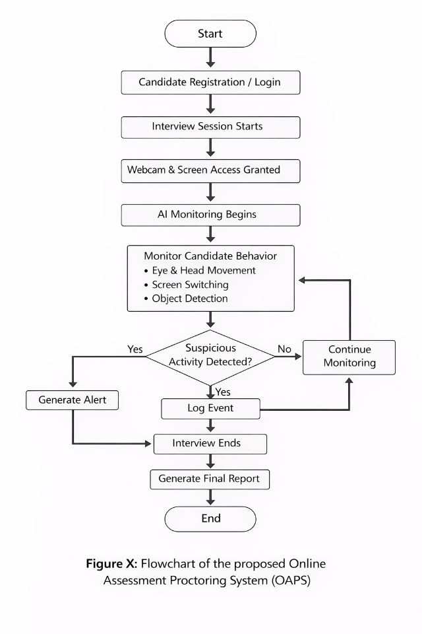
Figure 1.1

CV Module (Gaze Monitoring)
The computer vision module captures live video from the candidate’s webcam during the interview session. The system integrates Artificial Intelligence using pre-trained computer vision models executed directly within the browser. MediaPipe Face Mesh (AI Powered CV Framework) is utilized for real-time facial landmark detection, enabling gaze estimation. MediaPipe FaceMesh detects 468 facial landmarks on the face in real time.
Steps:

The webcam captures live video frames of the interviewee.

MediaPipe FaceMesh detects facial landmarks, including eye contours and iris positions.

Eye landmarks are extracted to calculate the relative position of the iris within the eye region.

A rule-based logic is applied to determine gaze direction.

If the gaze remains away from the screen beyond a defined threshold, the system flags it as suspicious behavior.

Screen Monitoring Module
This module continuously tracks screen activity during the interview session using Browser Visibility API. It detects screen switching, application changes, and browser tab transitions. Any unauthorized activity, such as frequent screen changes or access to restricted applications, is logged and reported to the backend system for further evaluation.
- Object Detection Module
This module involves use of TensorFlow’s COCO SSD Object detection Model to detect use of unauthorized rescources like mobile phone, and headphones.
Steps:
- Webcam frames are converted into tensors.
- The COCO-SSD model processes the frames to detect objects.
- Detected objects such as mobile phones or books are identified.
- If an unauthorized object is detected, an alert is generated and sent to the interviewer.
- Interviewer Dashboard (Frontend Interface)
Web-based dashboard is developed for interviewers and interviewees to start the interview.

Project Proposed Time Schedule

Activity | Month1 1 | Month 2 | Month 3 | Month 4 | Month 5 | Month 6
Literature Collection | ✔
Literature Study | ✔ | ✔
Analysis of Proposed Scheme |  | ✔
Dataset Collection & Preparation |  | ✔ | ✔
Model Development & Training |  |  | ✔ | ✔
Model Analysis & Implementation |  |  | ✔ | ✔
WebApp Development  (Mern) |  |  |  | ✔ | ✔
System Integration & Testing |  |  |  |  | ✔
Result Analysis & Evaluation |  |  |  |  | ✔
Final Write-up & Report  Submission |  |  |  |  |  | ✔

Table 2: Proposed time schedule

Budget Description
This project does not require any additional financial resources. All development and testing activities will be performed using personal laptops, built-in webcams, and freely available software tools and frameworks. Therefore, no external funding or specialized hardware is required for the successful completion of this project.

Estimated Budget

Item | Description | Cost (PKR)
Computing Resources | Personal laptop and free cloud tools | 0
Camera | Built-in webcam | 0
Software Tools | Open-source libraries and frameworks | 0
Total Cost
  - PKR

References
- Maria Ahmad And Ghassan Mohammad, “Advancements in Automated Cheating Detection Systems for Online and In-Person Examinations: A Comprehensive Review of Methods, Technologies, and Effectiveness”, IJMRAI, vol. 1, no. 2, pp. 131–142, Dec. 2025

- N. Taskin, “Cheating and prevention strategies in online assessment,” Teach. Assess. Era Educ. 5.0, no. June, pp. 161–172, 2024.

- K. Lee and M. Fanguy, “Online exam proctoring technologies: Educational innovation or deterioration? ,” Br. J. Educ. Technol., vol. 53, no. 3, pp. 475–490, 2022.

- AC. Ozgen, M. U. Öztürk, O. Torun, J. Yang and M. Z. Alparslan, "Cheating Detection Pipeline for Online Interviews,"Signal Processing and Communications Applications Conference (SIU), pp. 1-4, June 2021.

- I.Jegham, A. Ben Khalifa, I. Alouani, and M. Mahjoub, “Vision-based human action recognition: An overview and real-world challenges,” Digit. Investig., vol. 32, p. 200901, Mar. 2020.

Undertaking
Write the undertaking about the originality of project here.

Ramla Rahman and Adila
ID: 20949, 20397

Supervisor’s Comments
Take recommendation of your supervisor for your project work here.

Muhammad Abrar Khan
Lecturer

Final Year Project Coordinator Remarks
Do not write anything here. For official use only.

Signature of Final Year Project Coordinator

Designation

